Setting Up BibleWorks
Part 5: BibleWorks Resources

Setting Up Resources
Move to the right panel (called the Analysis Window) and click on the “Resources” tab. You are usually going to want to have the "Summary" subtab as the foreground one. We are going to look at the other sub-tabs to set up the order of resources that appear in the Summary one. Note: You may not have all the resources that I mention. Ones in bold italic are addon modules you can buy. Italic indicates user created downloadable ones.
- LEXICONS: Put the Lexicons in this order by clicking on one of the lexicons and then using the little up/down arrows at the bottom of the panel (next to “Clear All”) to move it.
GREEK: Gingrich, Friberg, Bauer-Danker=BDAG, Balz-Schneider=EDNT, Louw-Nida, Lust-Eynikel-Hauspie=LEH, Liddell-Scott abridged, Liddell-Scott unabridged, Barclay-Newman (which you can uncheck), Moulton-Milligan, Thayer, Kittel-Bromiley = abridged TDNT, Preuschen (uncheck unless you want German).
Note: BDAG is the most respected lexicon for the Greek NT, but Balz-Schneider is also extremely helpful. (Both are separate purchases for BW.) GING (unfortunately, it is the 1965 and not the 2009 edition) is a condensed version of BDAG and is a quick way of seeing a word’s range of meanings. Do consult Friberg and Louw-Nida as well.
HEBREW: Koehler-Baumgartner=HALOT, Holladay, Brown=BDB, Harris=TWOT, Klett (uncheck unless you want German).
Note: HALOT (purchased separately for BW) is probably the definitive Hebrew lexicon, and Holladay is a condensed version of it. BDB was and remains a standard lexicon, so you may wish to prioritize it over Holladay.
Your final result should look like this:
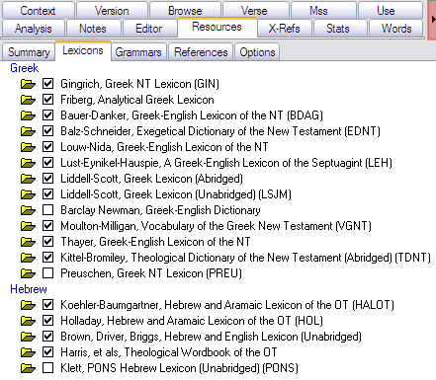

- GRAMMARS: Click on the Grammars subtab. I think it is easiest to select them all. (Note "Select all" at the bottom of window.) I would put them in this order.
GREEK:
  - Wallace’s Exegetical Syntax = Greek Grammar Beyond the Basics, BDF, Robertson, Zerwick, Burton, Conybeare, Davis, Croy, Goodwin, Smyth, MacDonald, BibleWorks.
  - HEBREW: Waltke & O'Connor, Weingreen, Gesenius, Joüon-Muraoka, Futato's Basic Hebrew, Futato's Begininning Hebrew, Davidson, BibleWorks Hebrew, BibleWorks Aramaic, Stevenson.
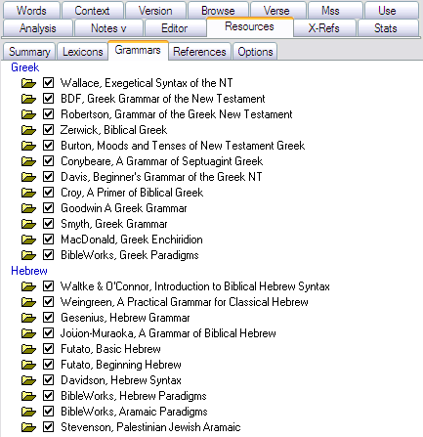

- REFERENCES: I pretty much leave everything checked under the “References” tab, but you can see by the graphic below some choices I make.
  - I uncheck a number of theological / confessional resources. I uncheck the Matthew Henry commentary. This commentary was written in 1706. It may have devotional value, but it is not particularly reliable and certainly not up to date!
  - Note: I probably have many more here than you have on your system. Many of these are user-created modules that we will learn later how to install. Some of mine may show up differently than yours.
  - You can see the order and ones I’ve un/checked below. Basically I tried to organize the English resources thus:
Bible; Grammar/Lexical (Latin); Reference; Commentary; Jewish; Historical, Early Church; Confessional, Theology; Maps; Illustrations.
The Greek ones simply have the codices to the bottom.
(Note: The ESV Study Bible and the NET Bible will show up in your Resources tab, but they are more easily accessible in BW9 in the Verse tab. The same applies to the CNTTS Apparatus, Tischendorf's Apparatus, and Metzger's Textual Commentary.)
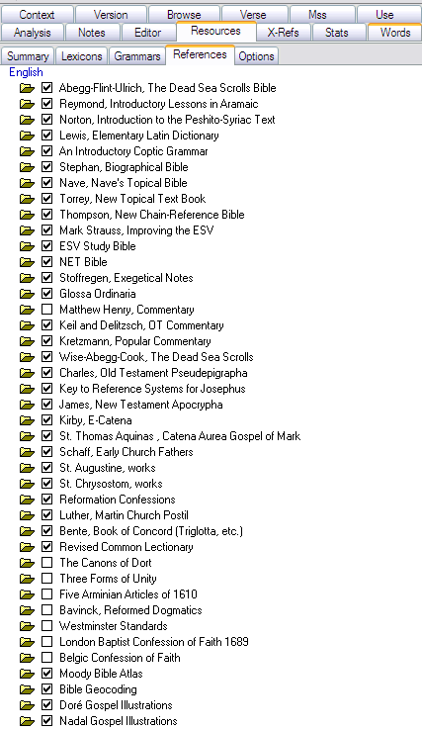 | 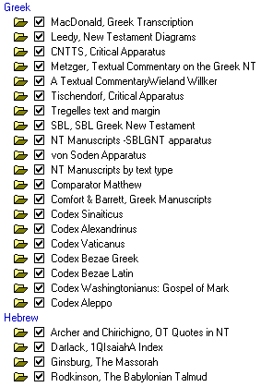

Finally, click on the Summary sub-tab again so that it will be the focus when you return to the Resource panel.

Using the Resources in BW
To see how to use the resources in BW, let's do a little exercise.
First, in the Analysis window on the right, click on the Resources tab and its Summary subtab.
Second, let's clear up the Browse window a bit by typing either:
- d c fav ↵ (d=display, c=clear everything out, fav=favorite IF you set this up in the earlier guide)
OR
- d c bgt nrs net ↵ (which just displays those three versions)
Now go to Mark 6:34 by using one of the following methods:
- Command line method:
  - Click in command line (or hit ESC 2x)
  - For most Bible books, you only need to type the first 3 letters. (You don't need to capitalize.) To indicate chapter and verse, you can use as a separator either a colon, comma, period, or space. (I find it easiest to use a space.) So:
  - type: mar 6 34 ↵
- Click and pick method
  - At the top of the Browse window, next to the little footprints, use the dropdown boxes so that you end up with this:
Next, move your mouse around over the Greek text. You should see things changing in the Resource tab. Move your mouse over the word ἐσπλαγχνίσθη, and you should see something (almost) like this:
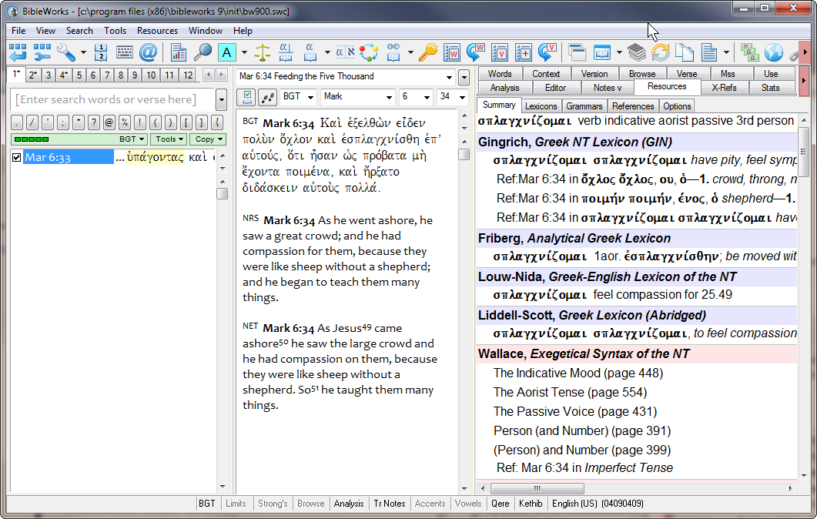
When using the Resource tab, you should note that:
- To keep the items in the Resource tab from changing as you move the mouse around, hold down the SHIFT key as you move the mouse. This freezes the Resource tab for the moment.
- The colored bars correspond to the various resources you just set up: purplish for lexicons, pink for grammars, and green for other references.
- Clicking on the colored bars does nothing.
- Note, for example, under the Gingrich Lexicon that the word the mouse is over is the first entry. BW is indicating that this word is in the lexicon. Clicking on it will bring you to that word in the lexicon.
- Note also, however, that below that first entry are 3 additional entries that start out with "Ref: Mar 6:34." These are other words in this verse, and BW is indicating that there is a specific reference to that word and it's occurrence in this verse. Clicking on one of those will bring you to that word in the lexicon with the passage reference highlighted.
- This is particularly important for the instances under Wallace, Exegetical Syntax of the NT. BW has recognized that there is at least one occurrence of a verb in the Indicative Mood and/or Aorist Tense and/or Passive Voice. If you click on one of those, it will bring you to general discussions of these topics. You will see that there is also one line for "Ref:Mar 6:34 in Imperfect Tense." This will bring you to a specific reference to Mark 6.34 in Wallace's grammar regarding a verb in the imperfect tense in this verse. (In this instance it happens to link to a footnote citing Mark 6.34 and suggesting that the imperfect διδάσκειν in the verse should be taken ingressively.
Go ahead and click on some of the links in the Resource tab to see what they are and how you can use them!

mgvh
2012.09

