Setting Up BibleWorks
Part 4: Setting Flags and Option Strings and Fonts

Setting Up Flags
- Use again to get into the BW Options Window and choose the Flags tab under General.
  - Expand the Command Line Search Options (click on the little + next to it):
    - You can leave everything alone, but check "Remember command line ranges"
  - Expand Search Window Configuration Options:
    - You can leave everything alone, but uncheck "Show morphology translation in Search Window..."
  - Expand Browse Window Configuration Options:
    - You can leave everything alone, but uncheck "Automatically make morphology versions display versions"
  - Expand General Greek Options:
    - You can leave everything alone, but check "Show entries from all Greek Lexicons..."
- Click OK to save and close all these option choices! Once you become more familiar with the program, you will be to come back and change things to ways that make better sense to you.
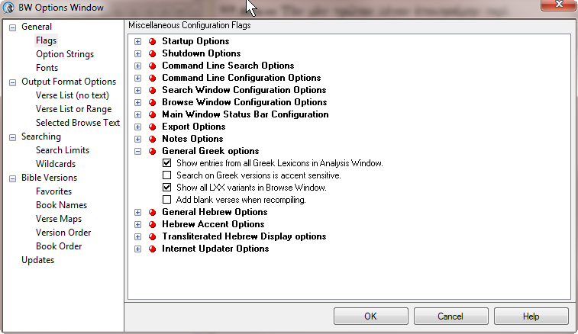

Setting Up Option Strings
- Use again to get into the BW Options Window and choose the Option Strings tab under General.
  - There is nothing that you necessarily need to do here, but there are a couple things to look at in case you need them later
  - Under Word Tips, you can choose to enable them or not (I recommend you leave them enabled), and you can choose whether to keep them open or not (I personally don't like them to stay open), and if you don't keep them open, you can choose how long to keep them open.
  - The other thing that often comes up on some computers/monitors is that the Found Text highlighting is too light. By default, it is light yellow. If you want to change it, click on the Background color and choose your favorite.

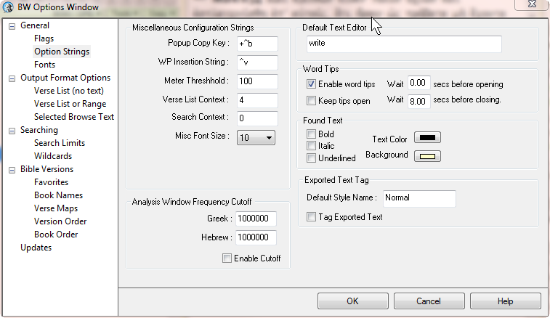
Setting Up Fonts
- NOTE: When you install BW9, it will install a few Greek and Hebrew Unicode fonts: Ezra SIL SR, SBL Hebrew, SIL Galatia, and SBL Greek. These are fine and attractive fonts that allow you to view Greek and Hebrew, but you still don't have a way to type in Greek and Hebrew in a word processor outside BW without a little extra work. To do so, the easiest way for now is to go to: "Fonts for Biblical Studies" (Tyndale House). Use the "Tyndale Unicode Font Kit" available for either PCs or Macs. Follow the installation steps, and you are set for now. During that installation, the "Cardo" font will be installed on your system. This is a very useful font because it is free, it includes both Greek and Hebrew and a full set of transliteration characters, and it is the font we use at LTSG in our handouts to you. You will see below, therefore, that I suggest you use Cardo as your export font.
- As in previous steps, use to get into the BW Options Window and choose the Fonts tab under General. In the upper right are 3 choices under “Font Set to Edit.”
  - Choose “Search Window Fonts.” This will depend on your eyes and your monitor, but I have my sizes set: English at 12, Greek at 14, and Hebrew at 18. Don’t change the fonts and don’t bother with anything else. If you decide the fonts are too big/small, you can always come back here and change them.
  - Now choose “Browse Window Fonts.” I use the same settings as the previous, but again, choose what works for you.
  - NOTE: On the far right is an "AW" column. This is for the Analysis Window which will appear on the right where your lexical and other information shows up. If you want to change the size of those fonts, do so now.
  - Now choose “Export Fonts”
    - Choose the English font and size (Use what you most often use in your word processor; probably something likeTimes New Roman at 12)
    - At the bottom of the window, for Unicode Greek, select Cardo (at 12)
    - For Unicode Hebrew, select Cardo (at 12 or 14)
    - Check all three boxes about exporting Greek/Hebrew and using Unicode at the bottom of the window
    - OK
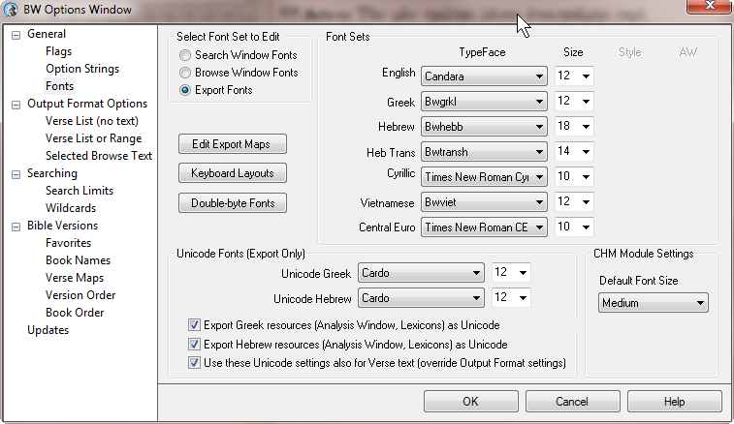
One other thing to note before leaving this window. BW uses CHM modules (they are like Windows Help file windows) for some linked resources. Note that you can change the size of the font in those popup windows here. mgvh 2012.09

