Setting Up BibleWorks
Part 3.3: Setting Up Versions – Parallel Version Favorites

Setting Up Parallel Versions Favorites
There are also times when you may prefer to see certain texts laid out side-by-side in vertical columns rather than the horizontal arrangement that is displayed in the Browse Window. A vertical arrangement also allows you to see more than one verse at a time. To make this happen, we want to set up some Parallel Versions Favorites.

- To make things easy, let's first get the versions we want to display
  - Go to the command line (Remember that you can use the ESC key to get there and hit it twice to go there and clear the line)
  - type: d c bgt nau kjv dra nrs net niv njb ceb nlt ↵ (<< add or subtract whatever versions you prefer)
- As in the previous step when we set up Search and Display Favorites (use ), get into the BW Options Window and go to "Bible Versions > Favorites"
- Still under the Versions tab, Add a “Parallel Versions Favorites”
  - In the bottom half of the screen under “Versions to Display in Parallel,” move the versions up/down to match the list above (unless you prefer to have the Greek=BGT in the middle with English versions on either side)
  - Rename this to GreekEnglishParallel > OK > OK
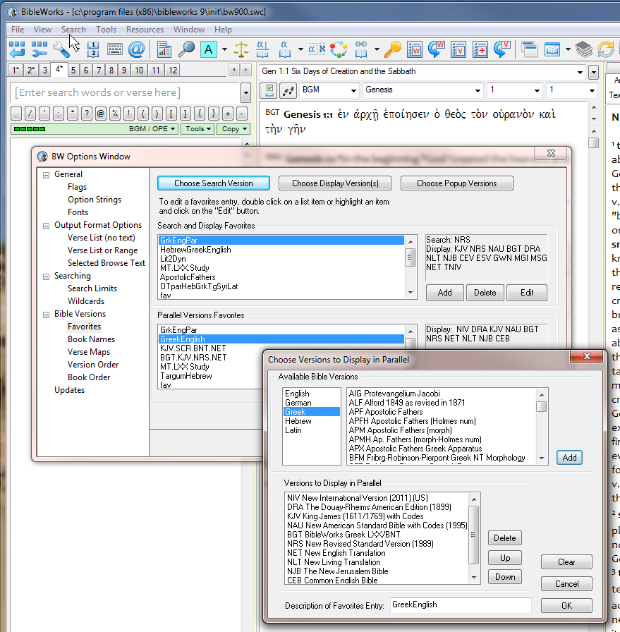

While we are here, let’s set up another “Parallel Versions Favorite” for use later.
- In the command line, type: d c kjv scr bnt net↵
- As in the previous step when we set up Search and Display Favorites (use ), get into the BW Options Window and go to "Bible Versions > Favorites"
- Still under the Versions tab, Add a “Parallel Versions Favorites”
  - Click on Add, then Edit
  - In the bottom half of the screen under “Versions to Display in Parallel,” make sure you just have KJV SCR BNT NET in that order
  - Rename this to GreekVersions >> OK >> OK

Using Parallel Versions Favorites
To activate the Parallel Versions Favorites you have created:
- Click on the down arrow next to the Parallel Versions icon which you set up in the button bar. (Cf. graphic below)
- Click on the favorite you want to use
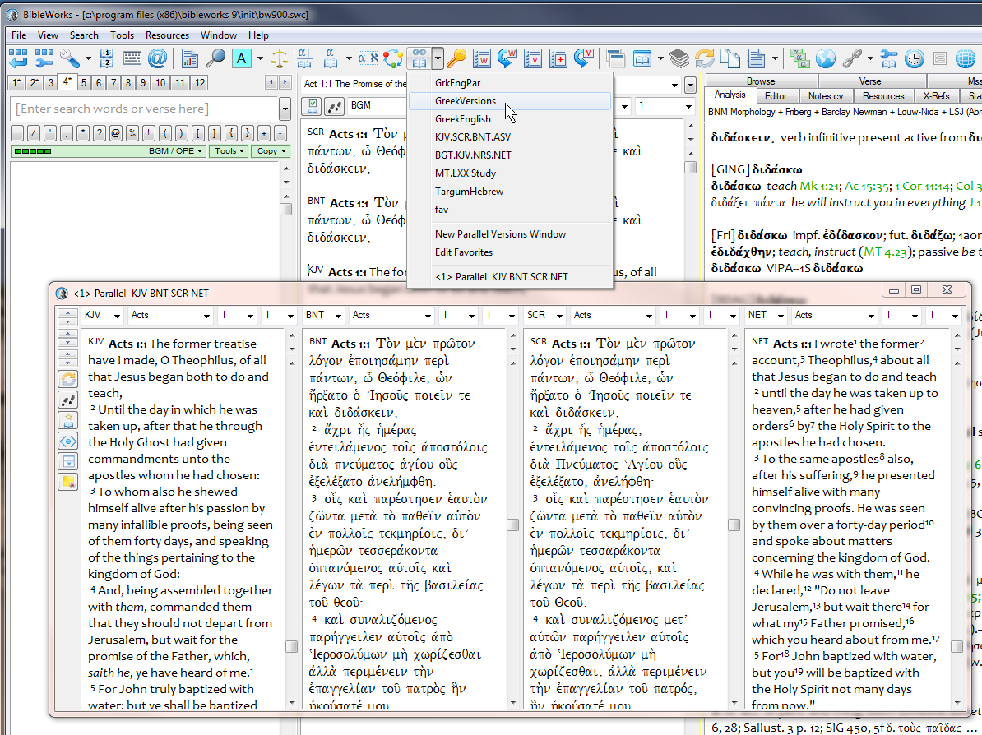

NOTE: Check out the How-To Video in BibleWorks (under Comparing Versions and Manuscripts) for more info on using this tool.
mgvh
2012.09

