Setting Up BibleWorks
Part 3.2: Setting Up Versions – Search and Display Favorites

Setting Up Search and Display Favorites
Depending on the kind of biblical work you want to do, you will want to have different groups of texts displayed. E.g., you can set up texts when you are interested in comparing the Hebrew Masoretic text and the Greek Septuagint or when you want to work on textual criticism of the Greek NT. You can create the groups of texts you want by setting Search and Display Favorites.

- First, we want to confirm that we have the versions handy that we used in the previous step.
  - Go to the command line (Remember that you can use the ESC key to get there and hit it twice to go there and clear the line)
  - type: d c ↵
  - type: d tnk wtt bgt lxa nau kjv dra esv nrs net niv tniv njb ceb gwn nlt ↵
- Get into the BW Options Window and go to "Bible Versions > Favorites"
(Remember click on the little setup wrench icon )
- Under Bible Versions on the left, click on Favorites
- To the right of the “Search and Display Favorites,” click Add, then Edit:
  - Under the Search Version pane, choose BGM under Greek
  - Under Display versions, click on “Show Only Active Languages”
  - At the bottom left, rename the Description to HebrewGreekEnglish > OK
- While we are here, let’s set up another “Search and Display Favorite” for use later.
  - Click on Add, then Edit
  - Under the Search Version pane, choose BGM under Greek
  - Under the Display Versions, deselect everything except BGT for Greek, WTT for Hebrew, and LXA and NRS and NET for English. At the bottom of the box, rename the Description to fav (for favorite) > OK
  - I use this group of texts when I want my Browse window to not be 'overwhelmed' with so many versions.

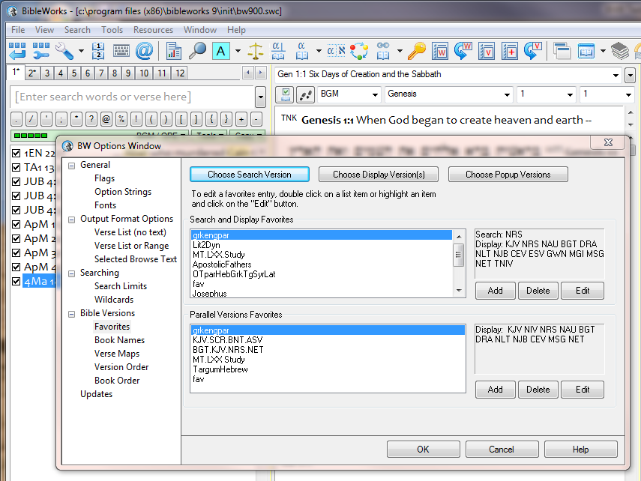

Using Search and Display Favorites
There are two ways to activate the Search and Display Favorites you have created.
- As in the previous steps, get into the BW Options Window and go to "Bible Versions > Favorites"
In the upper pane marked Search and Display Favorites, click the one you want and then click OK
- A faster way is shown below. Click on the green bar just below the command line, then click on the display favorite that you want.
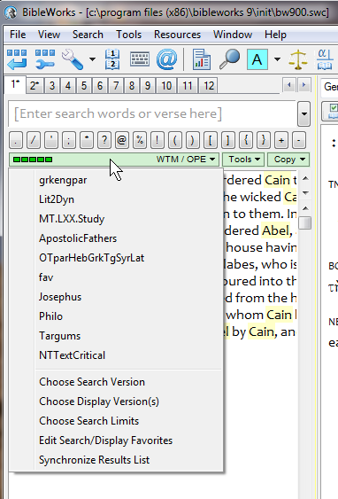
SHORTCUT TIP:
If you really want to see all your English (or Greek or...) versions at one time, type "d english" (or greek or...) on the command line and hit Enter.
SHORTCUT TIP:
The best way to get to your Search and Display Favorites is to left-click on the green bar.

mgvh
2012.09

