Setting Up BibleWorks
Part 2: Setting Up the Workspace

Here is what my BibleWorks layout looks like:
BUTTON BAR
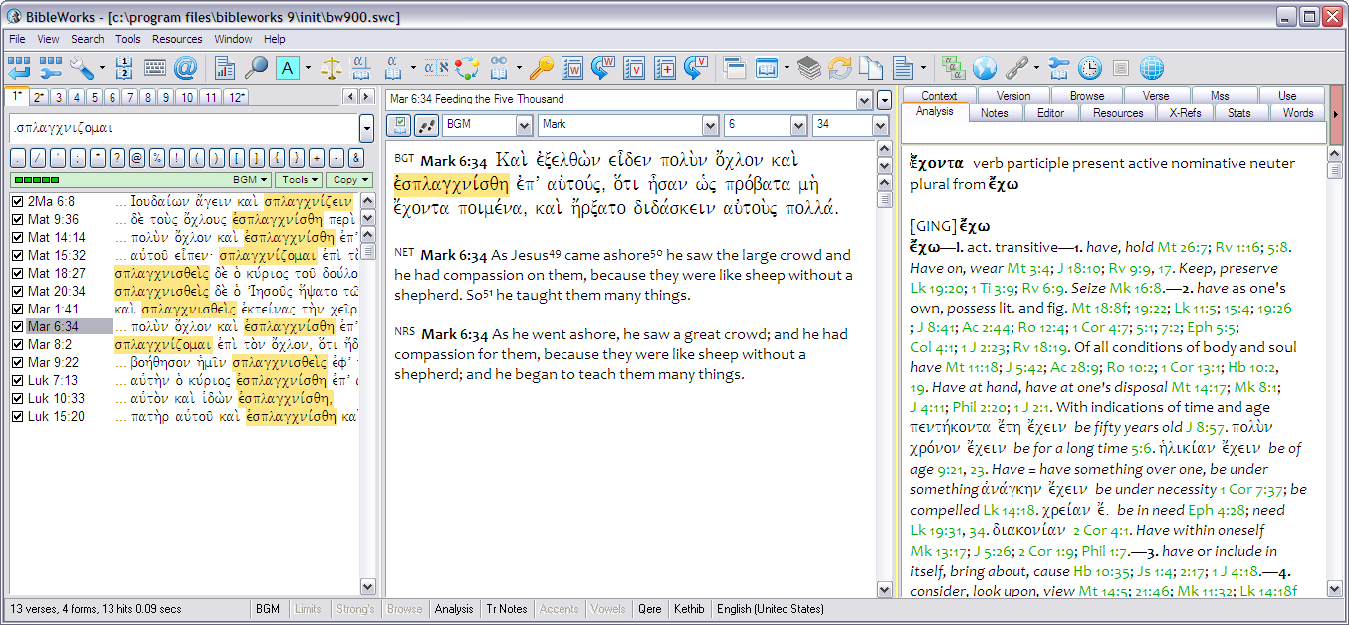
ANALYSIS WINDOW TABS
ANALYSIS WINDOW
BROWSE WINDOW
SEARCH WINDOW

I have thought about the ordering and grouping of the icons on the button bar. Here is my recommendation. I've grouped them into logical categories and add separators between each. There are two ways to move the button icons around.
- Access the button bar setup by clicking on the second icon (buttons with wrench). This way provides access to all the buttons.
- If you just want to move visible buttons around, hold the ALT key, then left-click and hold with the mouse on a button to reposition it.
TEXT TOOLS
SETUP
RELATED/EXT
EXTEND BW

  - SETUP: Button wrap/Customize/Setup/VDO/BW Keyboard/MorphologyAsst
  - TEXT TOOLS: VerseReport / GSE / Coloring / Compare / Diagram / Lexicon / Heb&LXX / Synopsis / Parallels / KWIC / WL Manager / Word History / VL Manager / Add to VLM / Verse History
  - EXTEND BW: Clone BW / New Browse Window / Resource Summary Window / Sync Windows / Popup Verse Copy/ RTF Editor
  - RELATED and EXTERNAL RESOURCES: Flashcard / Map / Edit External Links / Build User Version / Timeline / Outline / ERMIE

Go ahead and click on some of those buttons just to see what they do!

Let’s set up a few more things, and again, this is just a starting point for you based on my experience. Change these as you wish once you see how you use the program.

- Move the cursor to the command line, and right click with the mouse. I like to have checked “Code Insertion Buttons” and “Command Line Morphology Help.” | 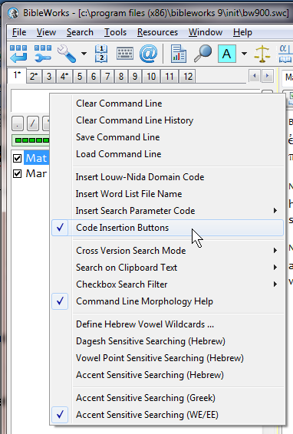
- Now right click somewhere at the top of the Browse Window (the middle panel) just above the text (in the area where you see the book, chapter, verse indicated). I like to have “Show Outline Heading” and “Show Browse List Boxes” checked. | 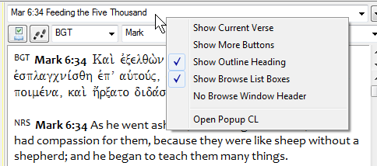

NOTES:
In terms of the display, there are many other possible options for your viewing pleasure.
- You can move the order of the tabs in the Analysis Window by grabbing and moving a tab.
- If you prefer to have the Analysis Window stacked below the Browse Window, use: View > Stack Analysis/Browse Windows. You can then adjust the height of the Analysis Window by grabbing the divider and moving it.
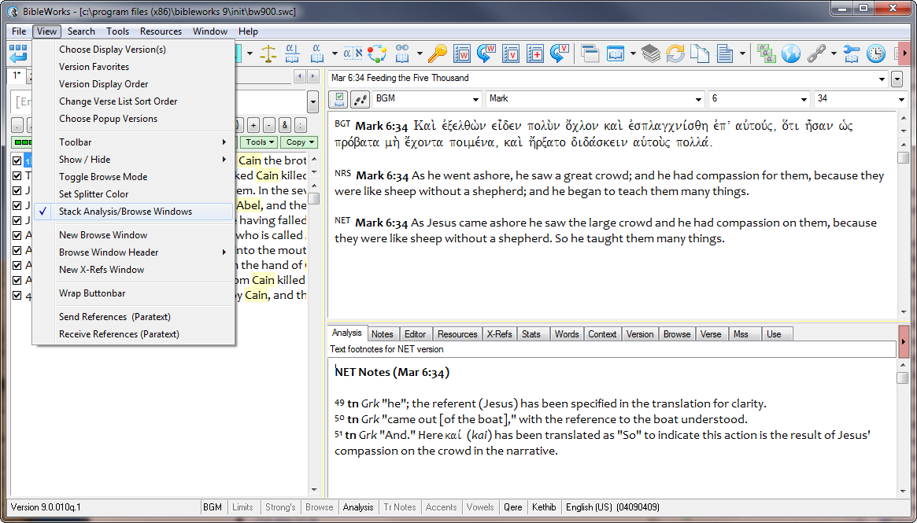
Fourth Column Popout Button
- If you want to give the Browse Window as much room as possible, you can hide the Analysis Window, either by View > Show/Hide > Analysis Window or by double clicking on Analysis at the bottom of the BW window.
If you would like to see more than one tab's worth of resources in the Analysis Window, note that you can click on the Fourth Column Popout Button. This is particularly useful if you are using a widescreen monitor. Note that the width of each window can be adjusted by grabbing and moving the vertical dividers. Further note that you can move the Analysis Window tabs to either column by grabbing and dragging them.
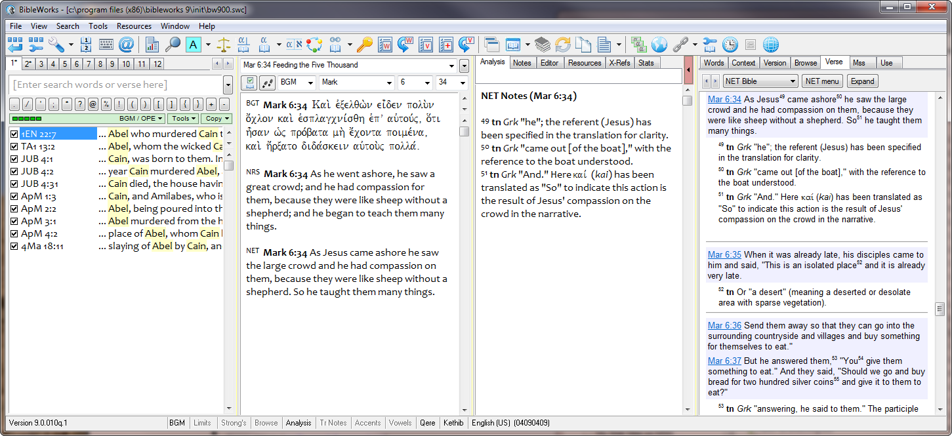
mgvh
2012.09

